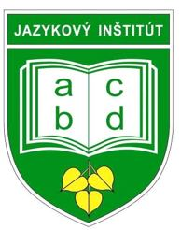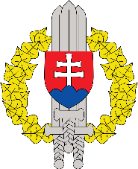

International English Language Conference
Liptovský Mikuláš, SLOVAKIA
DRAFT Conference Program
3 – 5 June, 2024

“AT EASE 2024”
DRAFT PROGRAM

Time | Activity |  | Location | Dress code
Sunday 2 June 2024
All day | Arrival
19.00-21.00 | Welcome Reception |  | TBC | Smart casual
Monday 3 June 2024
08.30-09.30 | Registration |  | Military Academy | Relaxed  Business
09.30-10.00 | Welcome address:  Host nation senior representative |  | Military Academy | Relaxed  Business
10.00-10.15 | Host nation presentation |  | Military Academy | Relaxed  Business
10.15-11.00 | Coffee Break/Group photo |  | Military Academy | Relaxed  Business
11.00-12.30 | Presentations/Plenaries/Workshops |  | Military Academy | Relaxed  Business
12.30-14.00 | Lunch (Military academy) |  | Military Academy | Relaxed  Business
14.00-15.30 | Presentations/Plenaries/Workshops |  | Military Academy | Relaxed  Business
15.30-16.00 | Coffee Break |  | Military Academy | Relaxed  Business
17.00-20.00 | Guided tour / Cultural evening |  | Liptovský Mikuláš | Smart casual
Tuesday 04 June 2024
09.00-10.30 | Presentations/Plenaries/Workshops | Military Academy |  | Relaxed  Business
10.30-11.00 | Coffee Break |  |  | Relaxed  Business
11.00-12.30 | Presentations/Plenaries/Workshops |  |  | Relaxed  Business
12.30-13.30 | Lunch |  |  | Relaxed  Business
13.30-14.30 | Presentations/Plenaries/Workshops |  |  | Relaxed  Business
14.30-15.00 | Coffee Break |  |  | Relaxed  Business
15.00-16.00 | Presentations/Plenaries/Workshops |  |  | Relaxed  Business
17.00-20.00 | Free evening / Cultural evening (based on interest) | TBC |  | Smart casual
Wednesday 05 June 2024
09.00-10.30 | Presentations/Plenaries/Workshops | Military Academy |  | Relaxed  Business
10.30-11.00 | Coffee Break |  |  | Relaxed  Business
11.00-12.00 | Presentations/Plenaries/Workshops |  |  | Relaxed  Business
12.00-13.00 | Host nation lunch |  |  | Relaxed  Business
13.00-13.30 | Wrap-up activities, Closing remarks |  |  | Relaxed  Business
13.30 | End of conference |  |  | Relaxed  Business

We particularly encourage you to participate in this new event with your contributions in PRESENTATIONS / DIGITAL POSTERS / WORKSHOPS. Without them we can't have the succesfull Conference.

Note: The Conference venue is the Slovak Armed Force Language institute.
It is customary for military personnel to wear civilian dress during the Conference.

